**Treller**

**Manage Tasks**

# What is it about?

Its Like Trello

# Details

## Boards

0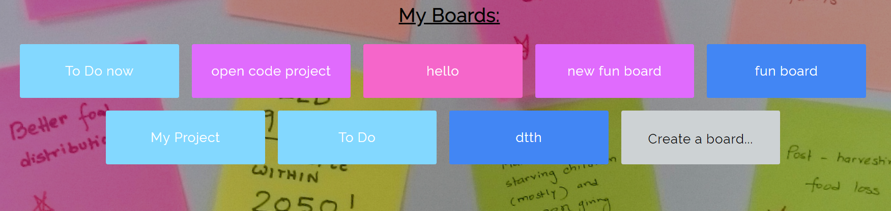

## Board Details

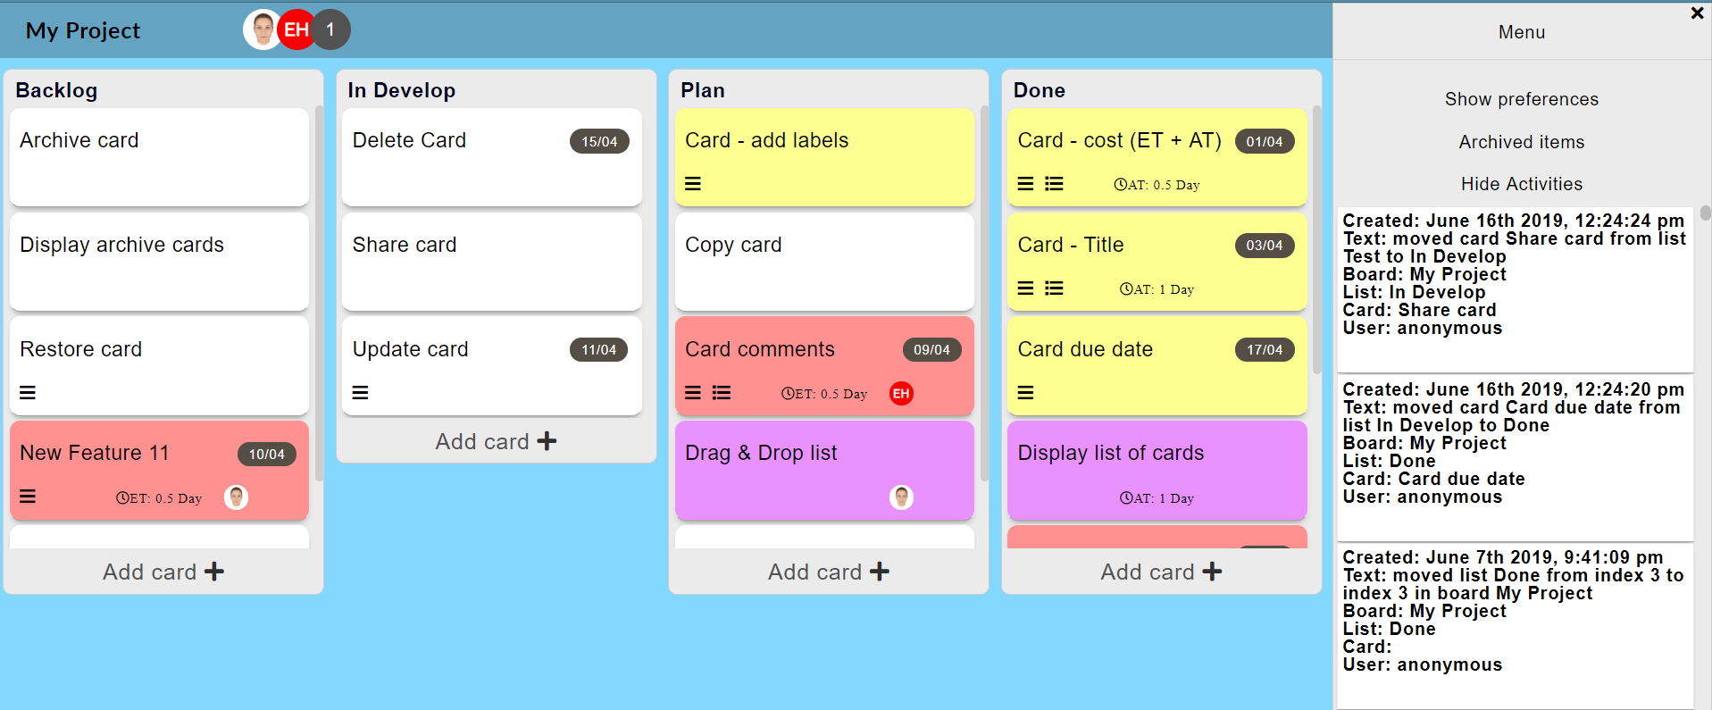

## Card Details

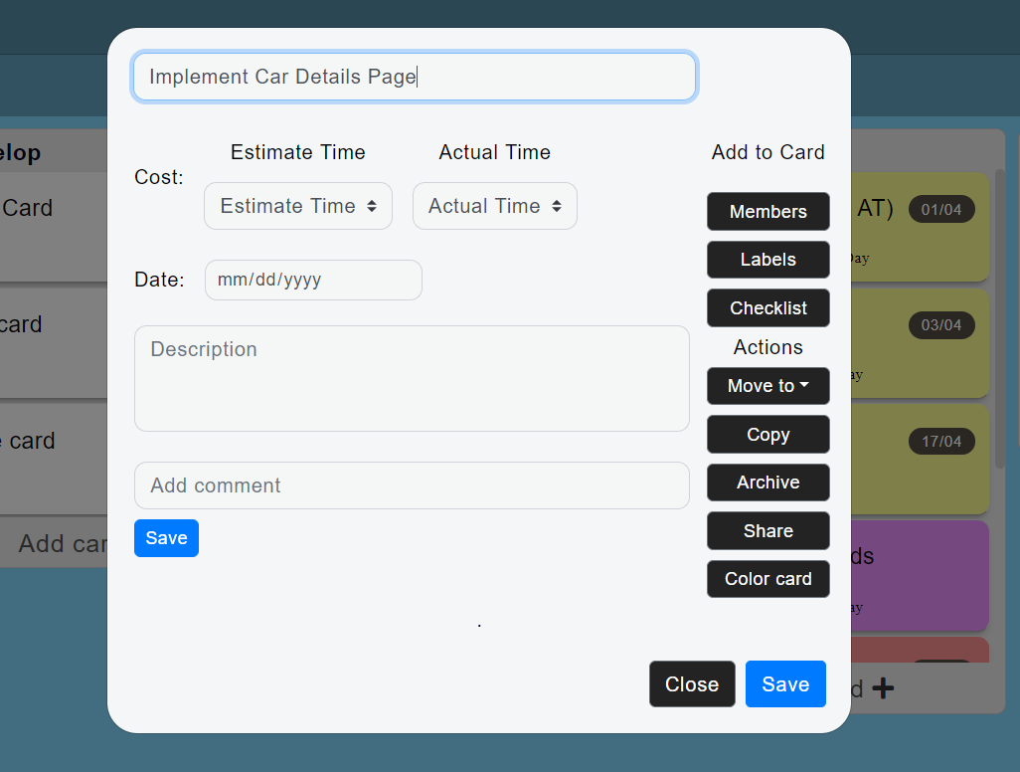

Tutorial screen

APIs:

- google\facebook quick authentication

- Habitica (crud, life\exp bar, progress bar)

- Telegram bot

- google calendar

- Ebay\Amazon API

- Whatsapp (https://api.whatsapp.com/send?phone=972525090552&text=hey%20dude,%20i%20checked%20our%20balance%20via%20HabiTerller%20and%20you%20owe%20me%206%20bucks?)

- url shortener

Charts:

- by date: daily charts, weekly charts, monthly charts

- by category

- by group

Icon +Splash

Export note\note list as CSV\PDF\txt\xlsx

External API (only if user is logged in)

IOU note -   
Yuval paid 5$ for coffee  
Aviv paid 30₪ for cake  
Gal paid 6€ for tickets

balance